**Publicis Sapient PJP Week1 – Assignment**

Narmatha Karuppasamy

Anna University, CEG

1.Part - A

I . Local repository

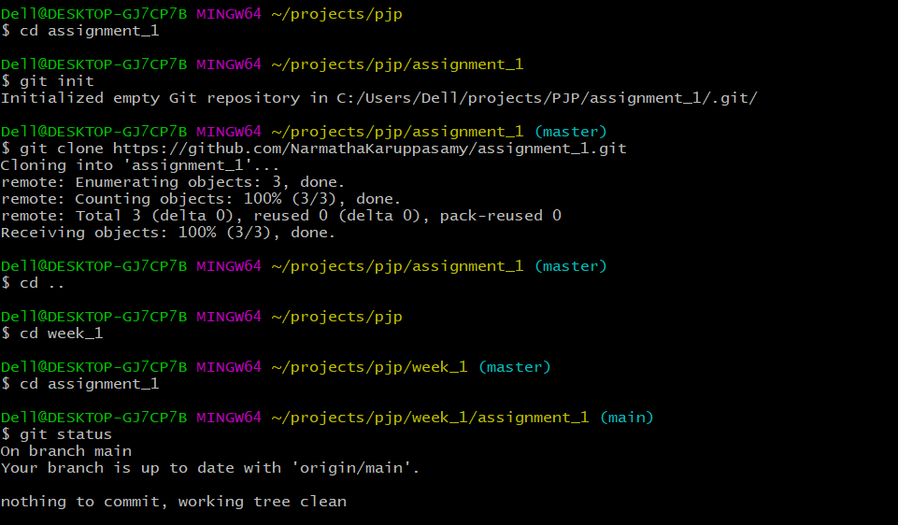

ii. Remote Repository

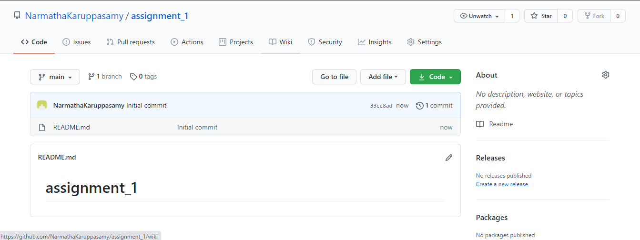

iii.local branches:

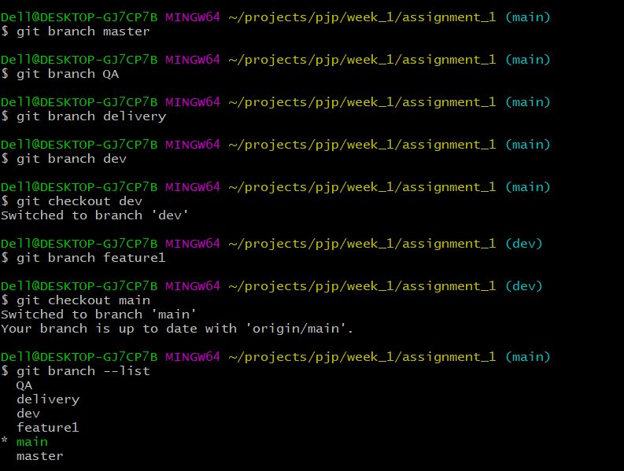

iv. remote branches

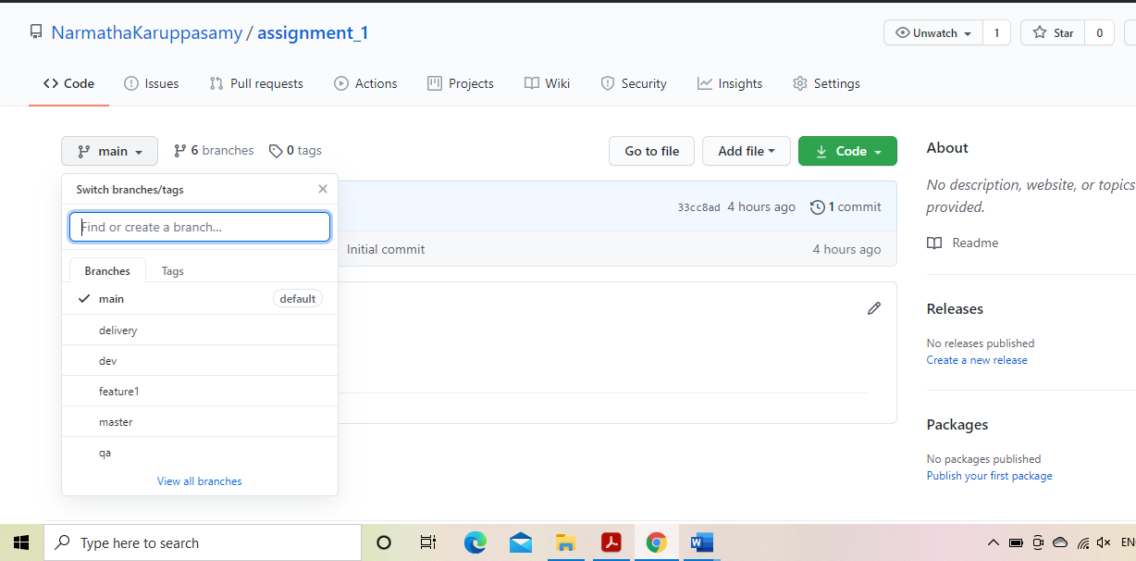

v)Add files and folder and remove files

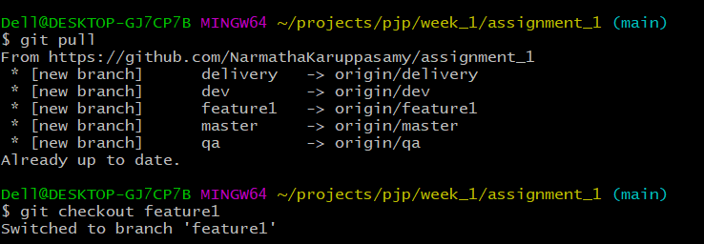

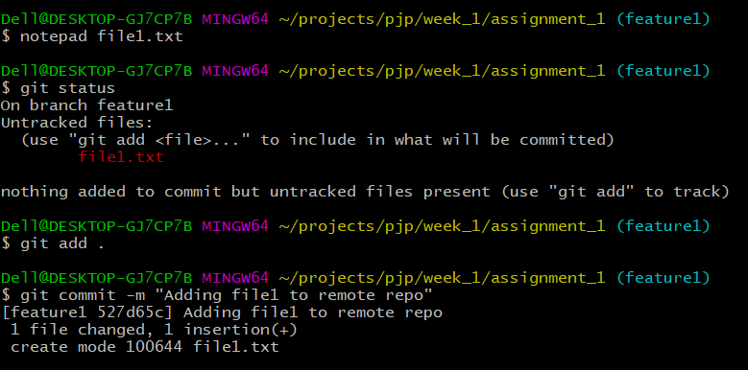

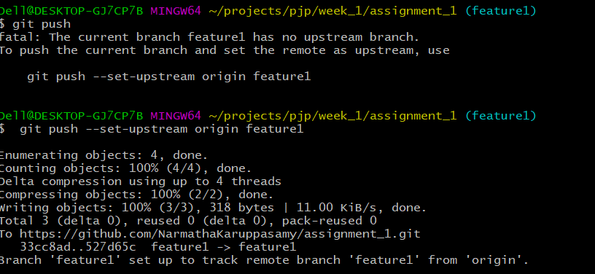

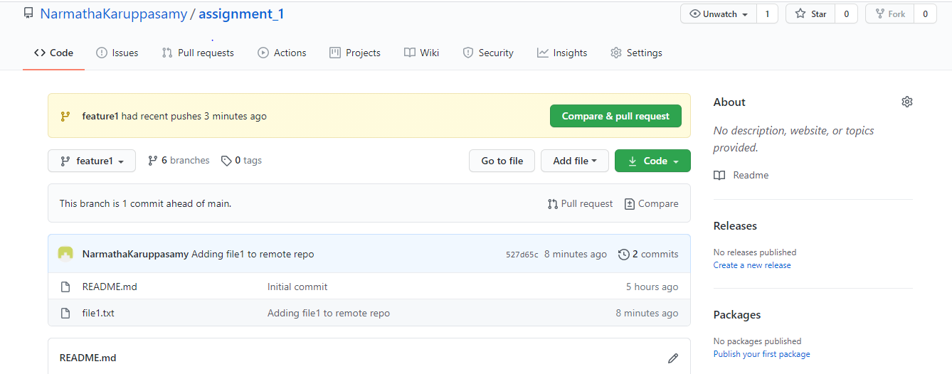

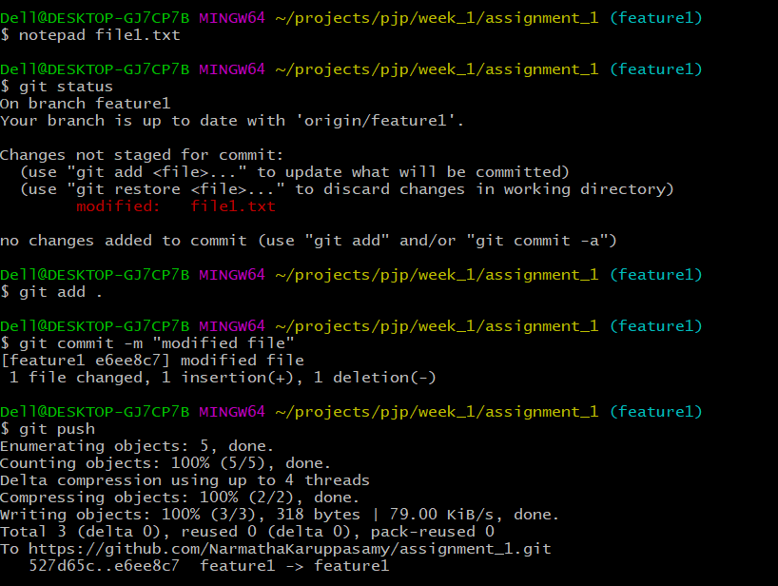

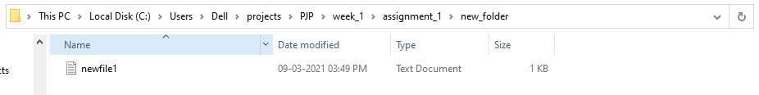

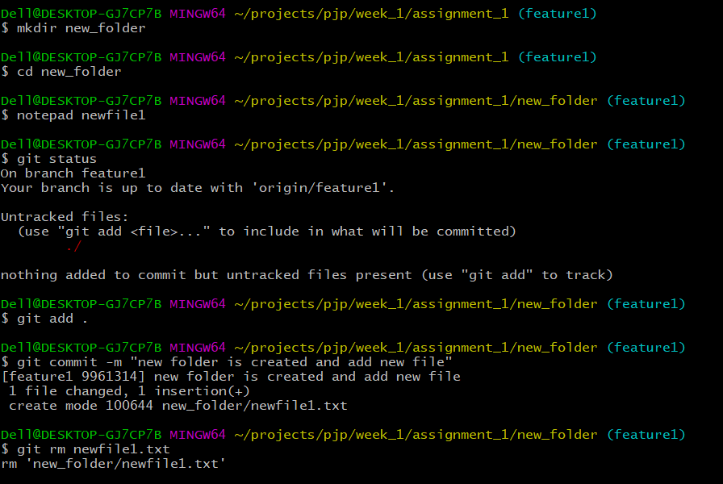

vi)Check -in, Stage, Commit, push into feature1

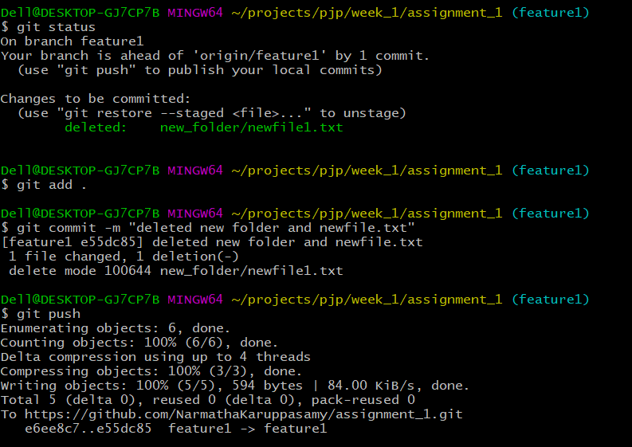

vii)Promote code from feature1 to dev

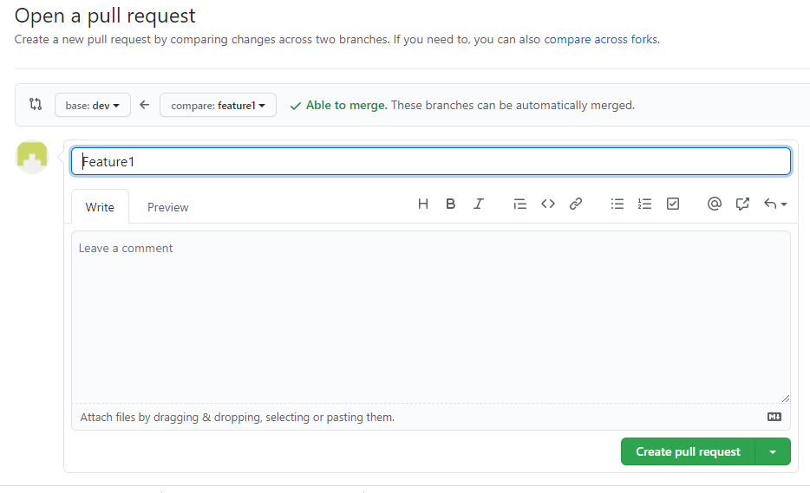

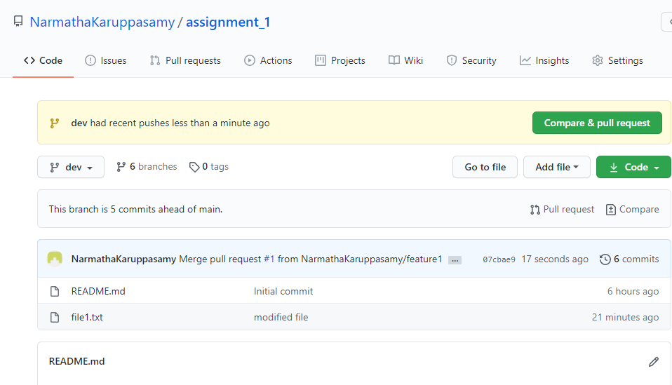

viii)Latest code from remote to local:

Pull updated local dev branch from remote repository

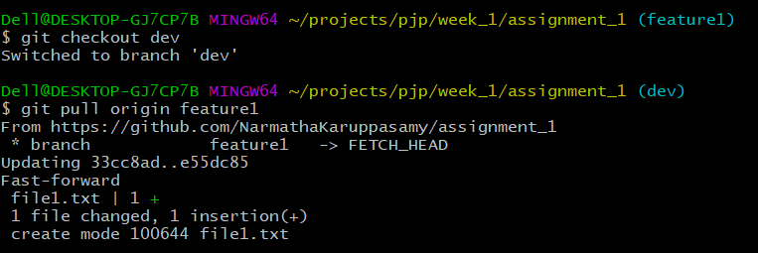

ix )Checkout Vs Pull:

Checkout: Check for the update in a branch but does not merge the updates.

Pull: Check for the updates and merges in local branch.

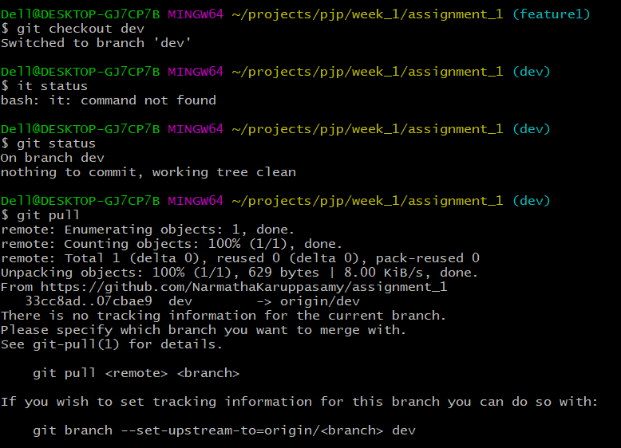

x ) Handle the merge conflict

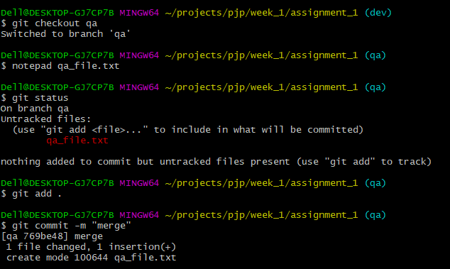

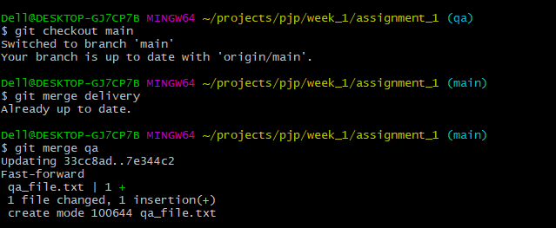

xi ). Ensure the code is in sync .with latest changes across all branches:

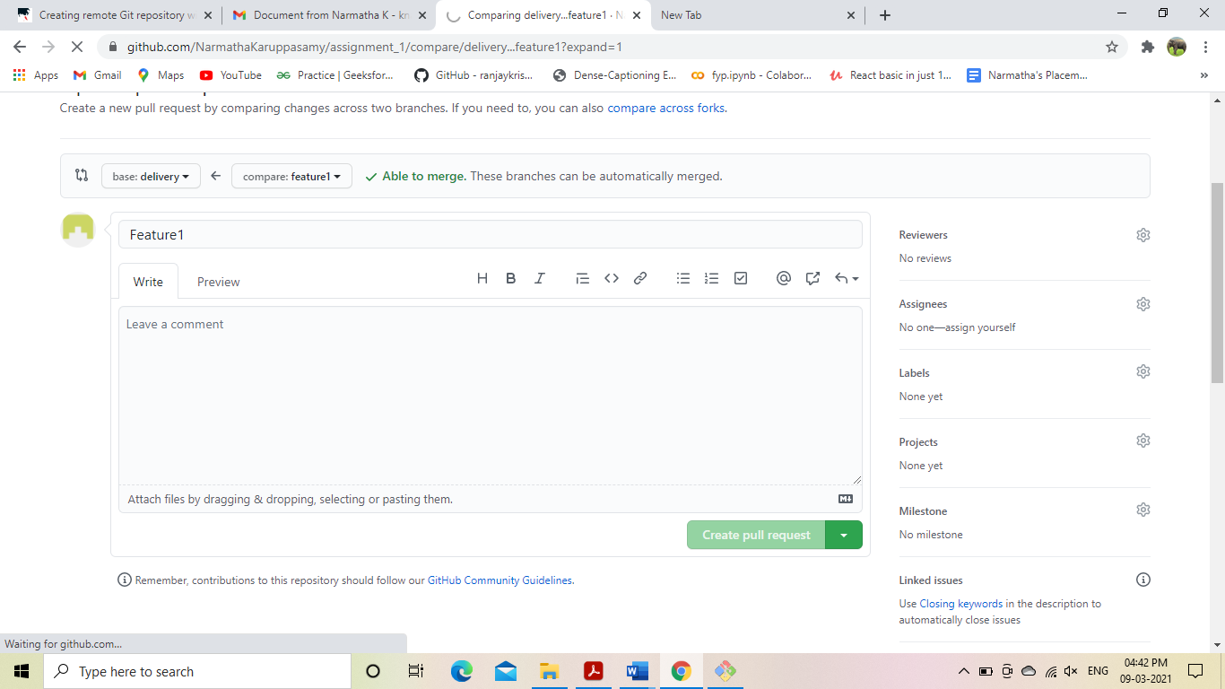

**GUI**

PART -B

I ) Local Repository

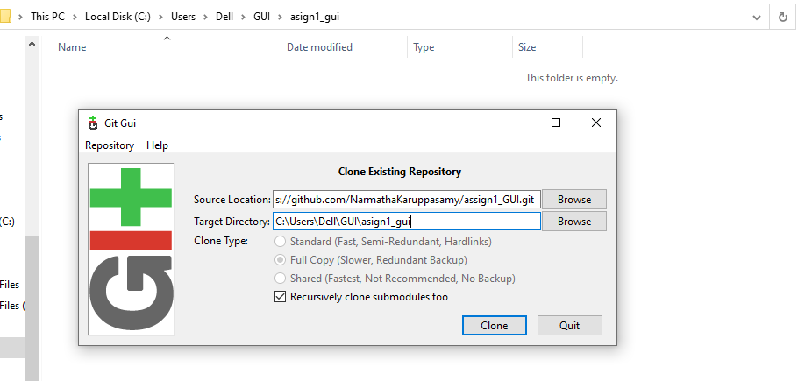

ii)Remote Repository

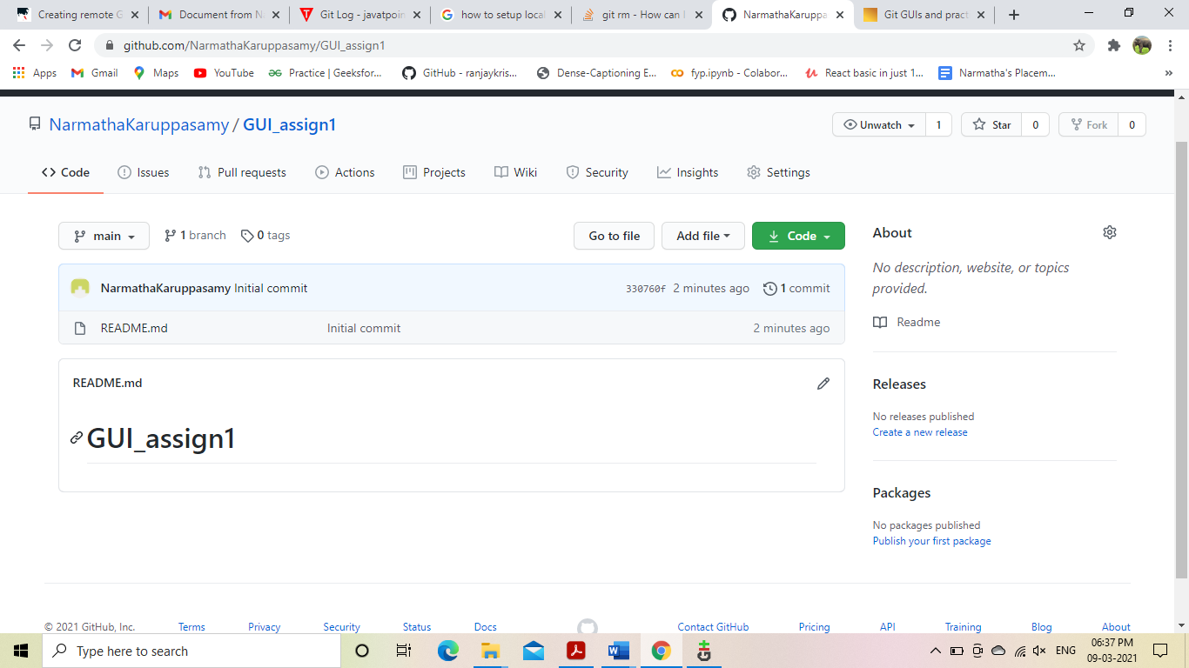

iii)local Branches:

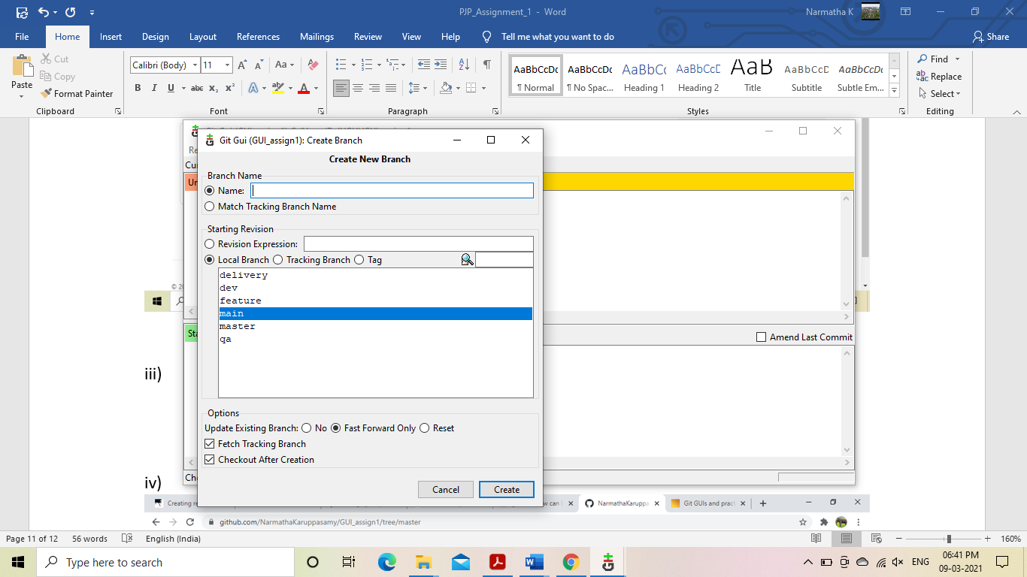

iv ) Remote Branches:

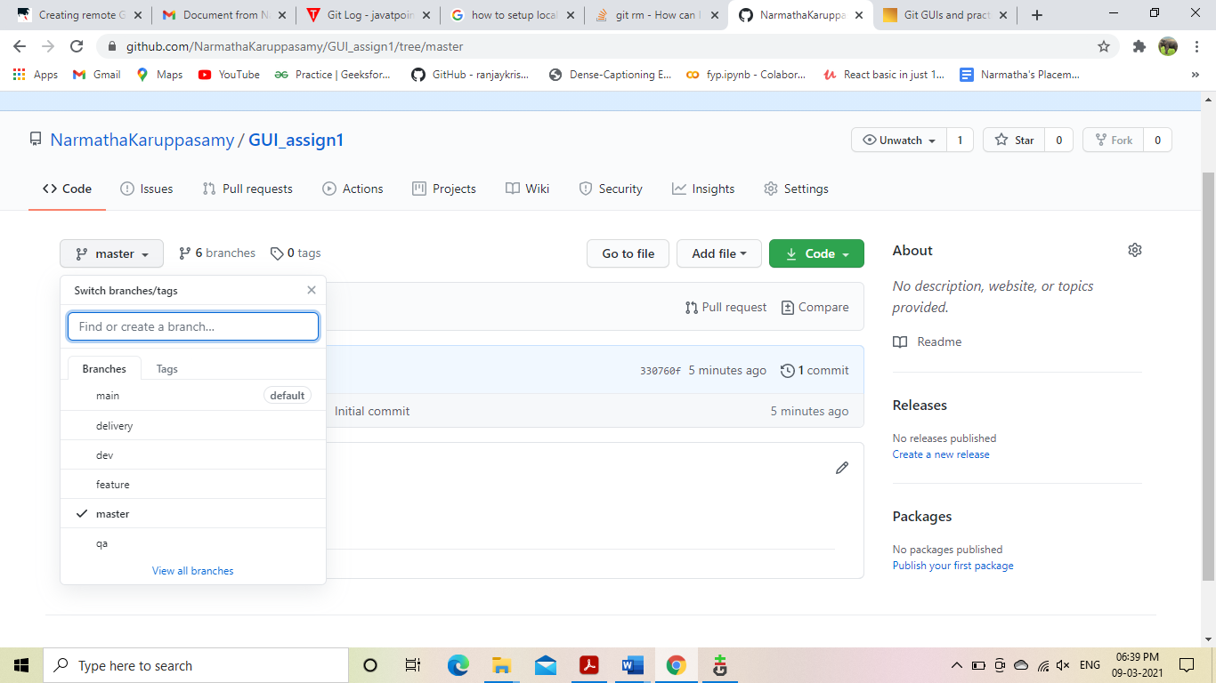

v)Add files and folder

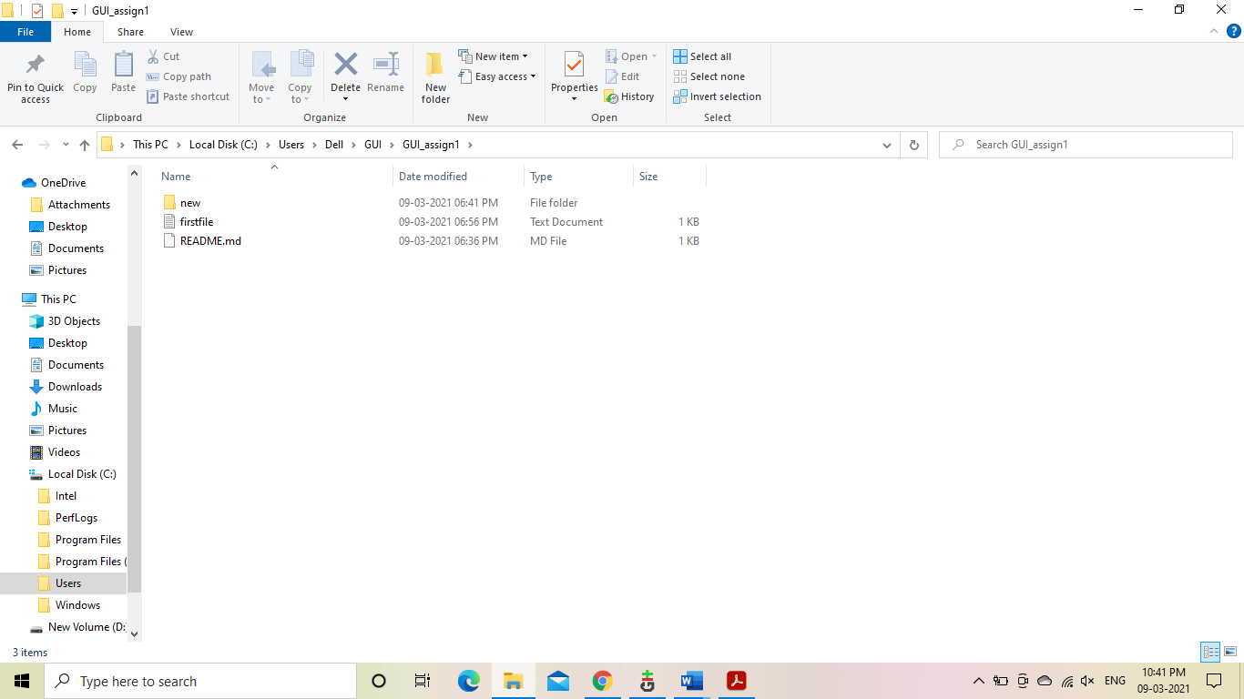

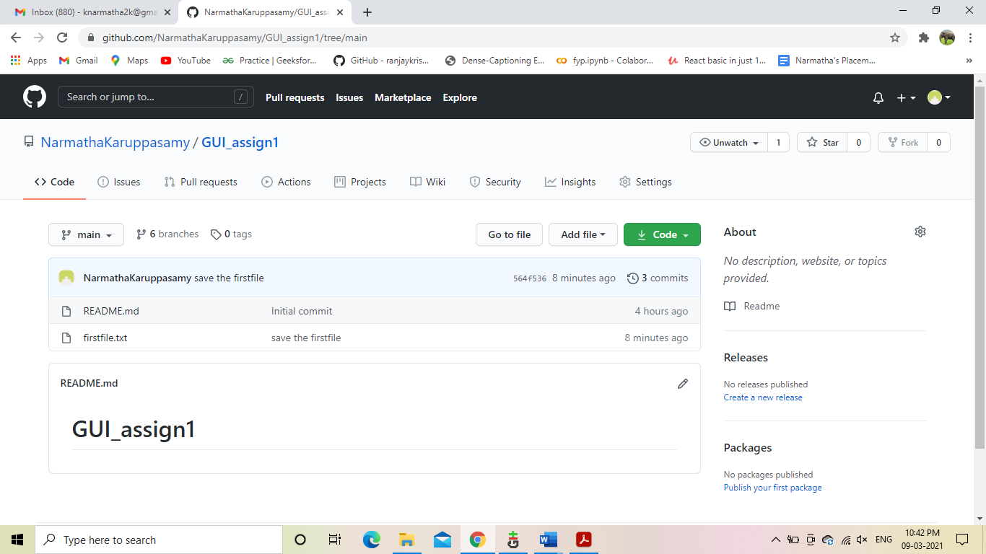

vi) Check -in, Stage, Commit, push into feature1

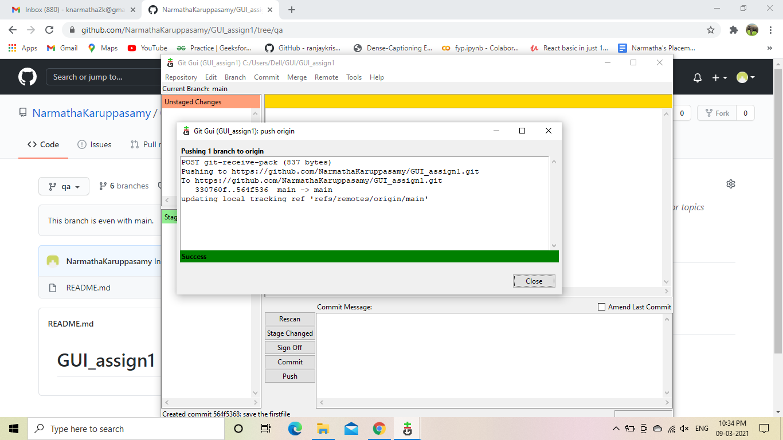

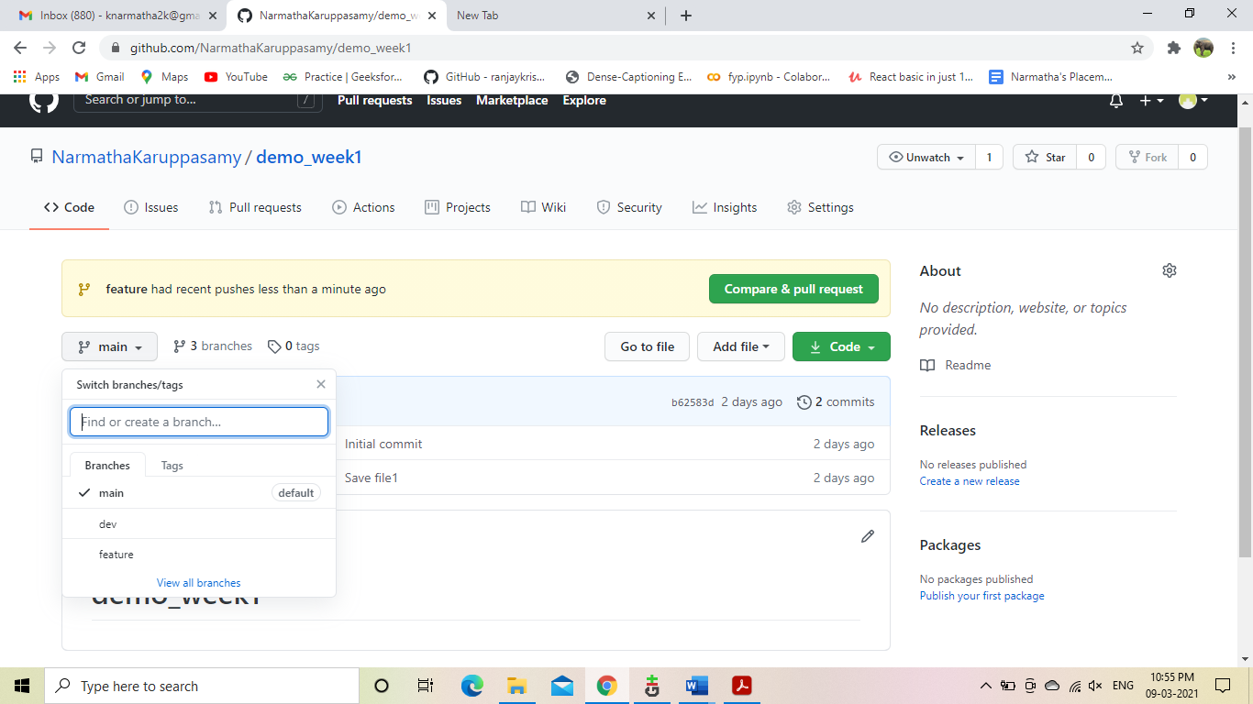

vii)Promote code from feature1 to dev

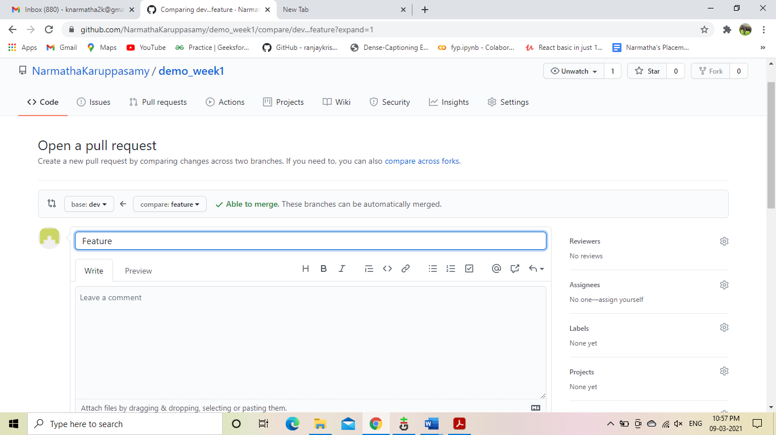

viii) latest code from remote to local

Fetch and merge into local repository

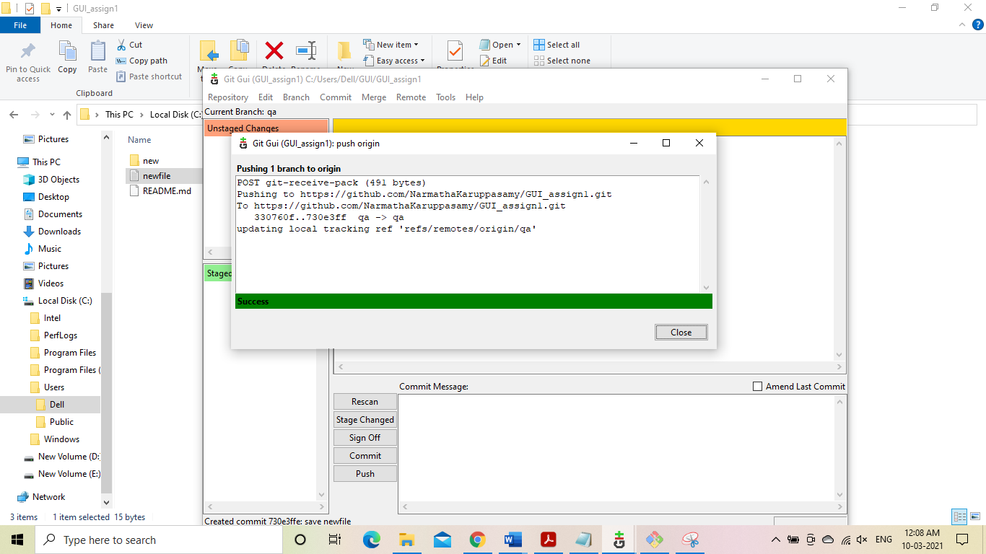

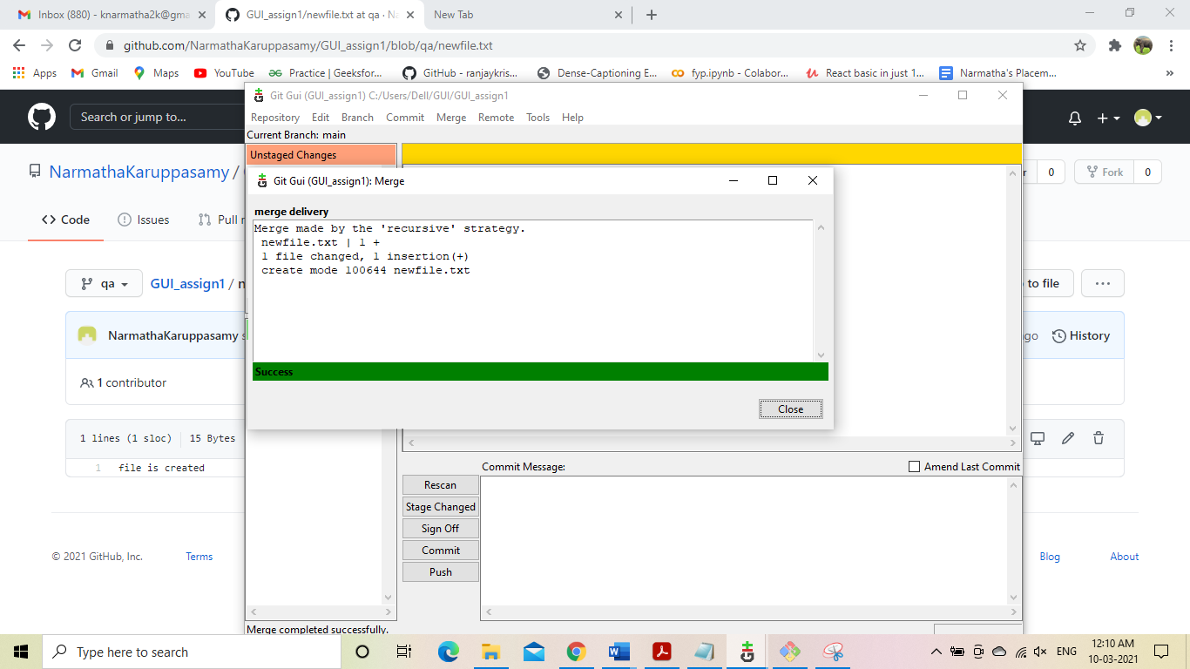

ix.Checkout Vs Pull:

It was defined earlier.

x.Handle Merge Conflict:

The Merge conflict was created by the same Merge Conflict method used above but here with the help of GUI Tool rather than CLI.

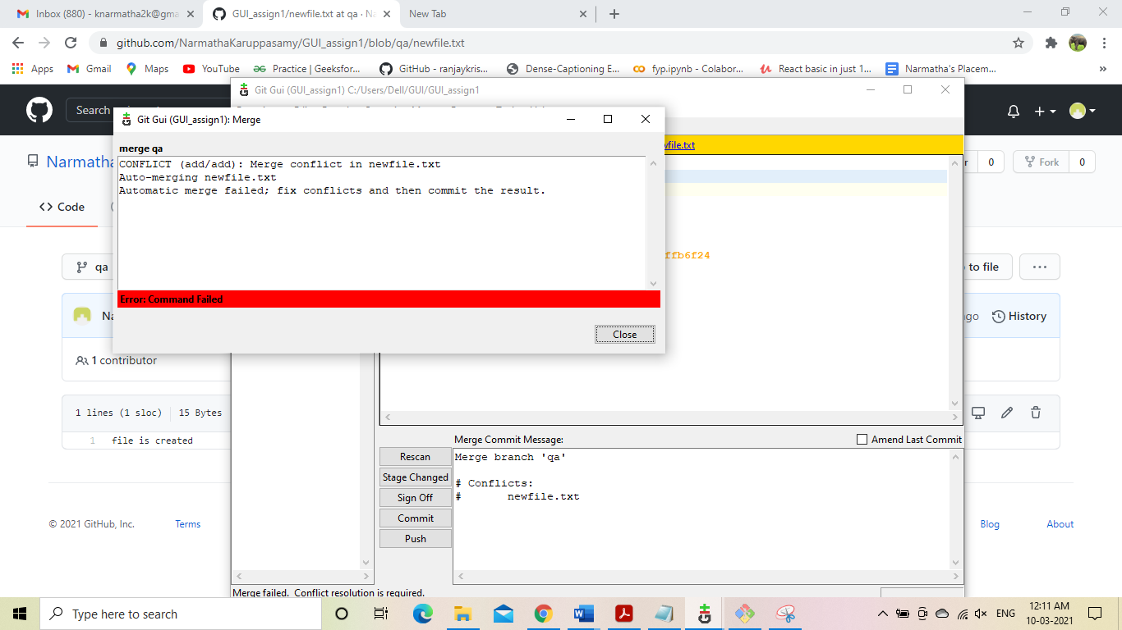

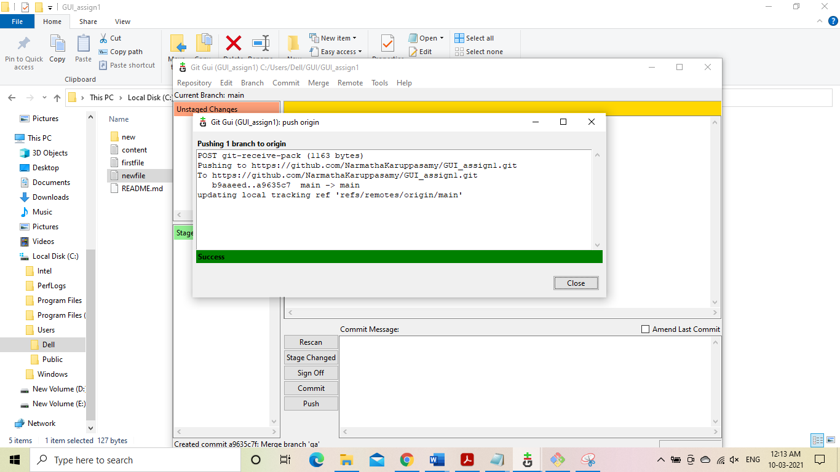

Solution:

Using Ctrl+T will resove this issue or commit->stage to commit.

xi.Ensure the code is in sync .with latest changes across all branches:

All File are updated to main.

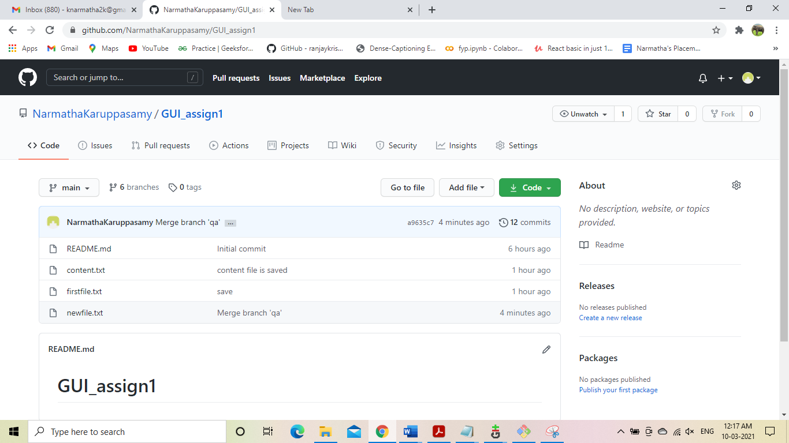

PART -C i)Reset or revert the changes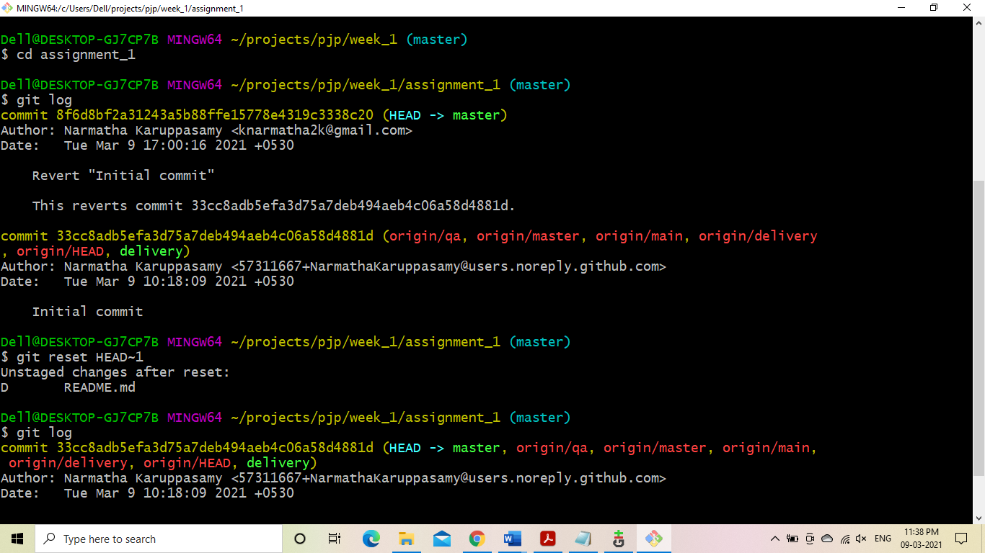

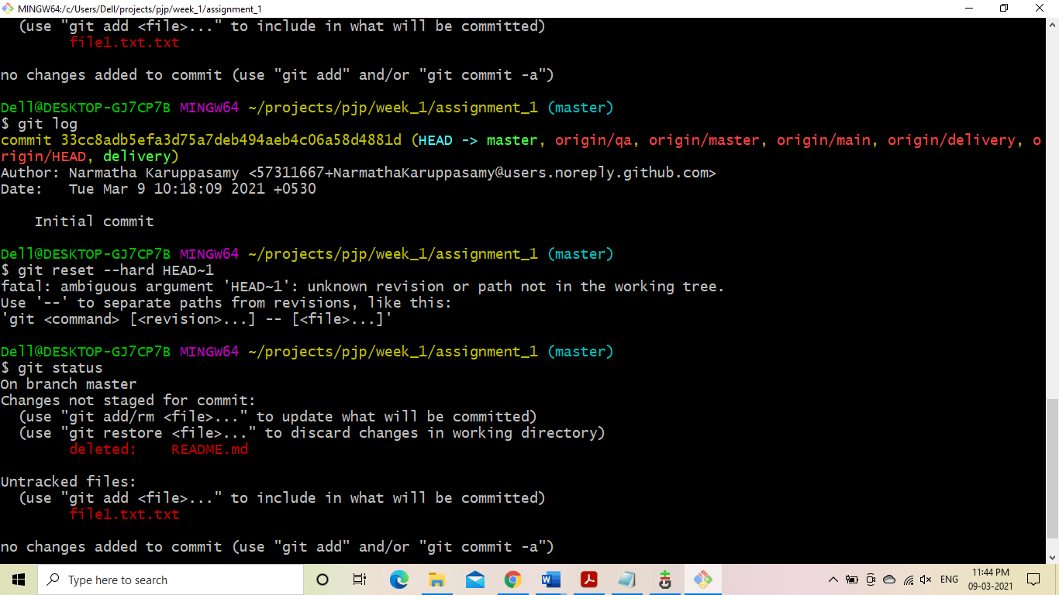

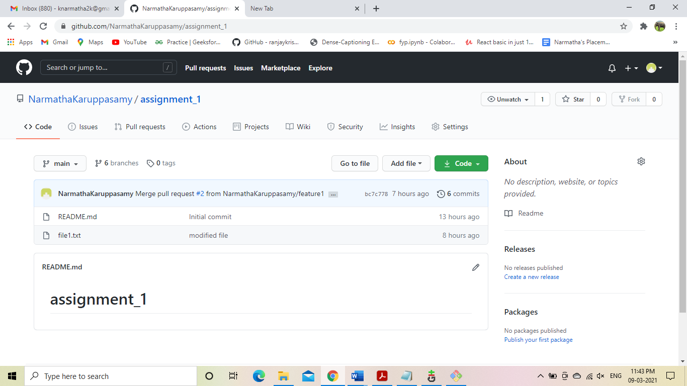

ii)Stash the local changes

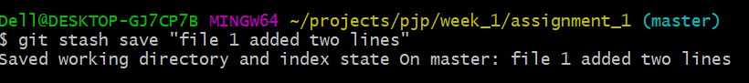

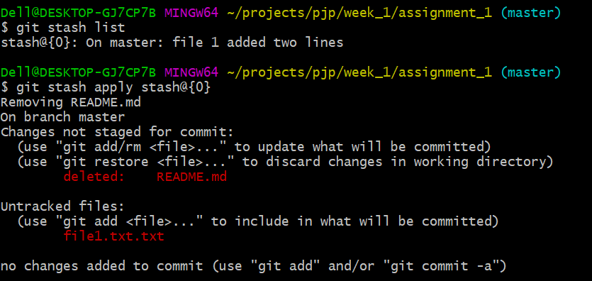

iii)Rebaseing

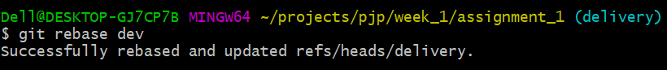

iv)git log,status,reflog

